

SEMESTER 1 EXAMINATION 2015/2016

Multi-Agent Systems and Distributed Artificial Intelligence

COMP30240

Prof. Simon Dobson
Prof. Padraig Cunningham
Dr. R. Collier*

Time allowed: 2 hours

Instructions for candidates

Answer question 1 and two other questions

Question 1 (compulsory). 50 marks in total

- List and define the four features that make up Wooldridge and Jennings weak notion of agency.
(8 marks).

- Autonomy: Agents operate without the direct intervention of humans or others, and have some kind of control over their actions and internal state.
- Social Ability: Agents interact with other agents and (possibly) humans via some kind of agent communication language.
- Reactivity: Agents perceive their environment (which may be the physical world, a user via a graphical user interface, a collection of other agents, the Internet, or perhaps all of these combined), and respond in a timely fashion to changes that occur in it.
- Pro-activity: Agents do not simply act in response to their environment, they are able to exhibit goal-directed behaviour by taking the initiative

- What is Speech Act Theory? List the five main categories of speech act as identified by Searle and give an example illustrating each category.
(13 marks).
- Definition (3 marks):
  - The origin of speech act theories are usually traced to the work of the philosopher John Austin.
  - Austin noticed that some utterances are like ”physical actions” that appear to change the state of the world. e.g.
    - Declaring war
    - ”I now pronounce you man and wife”
  - Austin distinguished 3 different aspects of speech acts:
    - Locutionary act - act of making an utterance
      - e.g. saying ”please make some tea” ’
    - Illocutionary act – action performed in saying something
      - e.g. he requested me to make some tea
    - Perlocution – effect of the act
      - e.g. he got me to make tea
- Categories + Examples (10 marks):
  - Representatives or assertives (informing) – it is raining
  - Directives (requesting) – close the window
  - Commisives (committing) – I will close the window
  - Expressive (express a mental state) – congratulations
  - Declaratives (effect some change) – I now pronounce you man and wife

- Explain what is meant by shared space communication. What are the advantages and disadvantages of this approach?
(10 marks).
Shared Memory (10 marks):
- Central memory store used to manage interaction.
  - Can be simple and generic (e.g. tuple spaces)
  - Can be complex and task-oriented (e.g. blackboards)
  - Distribution and replication can be used to improve reliability
- Benefits
  - Extensibility: all agents communicate via shared space
  - Better for sharing larger quantities of data.
  - Supports 1:m (broadcast) type communication
  - Easy to monitor and manage system activities
- Drawbacks
  - Loss of Privacy: information is public
  - Information Overload: must deal with large quantities of data

- What is the Agents & Artifacts model? How does it relate to environments? Describe the three the basic concepts of this model.
(6 marks).
A&A Model is based on Activity Theory (1 mark),

Relationship (2 marks): Environments are workspaces containing artifacts that agents create, share, use, adapt for their work.

Concepts (3 marks):
- Agents
  - Autonomous, goal/task oriented entities
  - Create and co-use artifacts for supporting their activities (in addition to direct communication)
- Artifacts
  - Non-autonomous, function oriented entities (controllable and observable)
  - Modelling the resources and tools used by agents (designed by MAS programmers; first-class entities for agents)
- Workspaces
  - Grouping agents and artifacts
  - Defining the topology or the computational environment

- Write an AgentSpeak(L) program to represent the following algorithm:

Algorithm: PrintEvens(x, y)
Print all the numbers in the range [x,y].

begin
count := 0
for all i in the range x to y inclusive do
if i is even then
count := count + 1
endif
endfor

print the message
"There are <count> even numbers in the range <x> to <y> inclusive"
end
(13 marks).

6 marks for the first rule, 3 marks for the 2nd rule and 2 marks for the 3rd and 4th rule

+!printEvens(X, Y) <-
+count(0);
!checkValue(X,Y);
?count(Z);
-count(Z);
print("There are " + Z + " event numbers in the range " +
X + " to " + Y + " inclusive").

+!checkValue(X,Y) : count(C) & X <= Y & X % 2 == 0 <-
-+count(C+1);
!checkValue(X+1,Y).

+!checkValue(X,Y) : X <= Y <-
!checkValue(X+1,Y).

+!checkValue(X,Y) <-
skip.

Question 2. 25 marks in total

- What is an Agent Communication Language (ACL)? What is the minimum set of features required for a functioning ACL? Why is this insufficient in practice?
(9 marks).
- An Agent Communication Language combines (3 marks)
  - a data format for representing speech acts.
  - a (partial) model of the state of the speaker and hearer.
  - a formally specified set of speech act types (based on the above model).

- Minimal Practical Form: performative, sender, receiver, content (3 marks)
  - request ( rem, bob ) “closed(door)”

- In theory: a speech act = performative verb + propositional content, but in practice contextual information, such as: who performed the speech act, and to whom it was directed. (3 marks)

- One of the FIPA standard Interaction Protocols is the FIPA Subscribe Protocol. Draw the Agent UML Interaction Diagram for this protocol.
(7 marks).
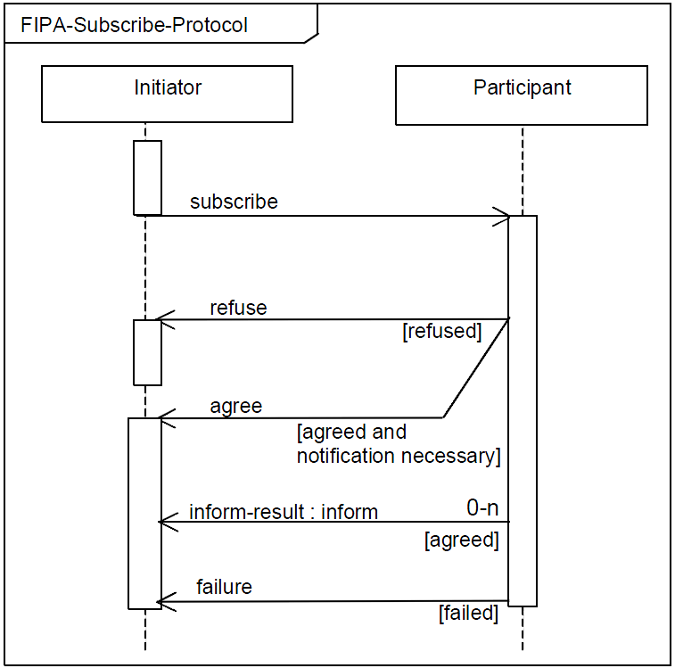

- A bookstore has decided to launch a FIPA compliant book announcement service. For this service, they expect customer agents to subscribe to the service providing information about the genres the customer likes. The service is managed by a book_service agent, and customer agents are identified by the customers email address. Give the sequence of messages that would be passed between the customer agent and the book_service agent for a customer with email address: bob@mail.com, who likes fantasy and cooking. As an example of a book that is announced, the book “Harry Potter and the Philosophers Stone” by J.K. Rowling.

NOTE: I want the messages to be specified in FIPA ACL with the content language being either ASTRA or Jason.
(9 marks).
(subscribe
:sender bob@mail.com
:receiver book_service
:language ASTRA
:content “book_service([\”fantasy\”,\”cooking\”])”)

(agree
:sender book_service
:receiver bob@mail.com
:language ASTRA
:content “book_service([\”fantasy\”,\”cooking\”])”)

(inform
:sender book_service
:receiver bob@mail.com
:language ASTRA
:content
“new_book (\”Harry Potter and the Philosophers Stone\”, \”J.K.Rowling\”)”)

Question 3. 25 marks in total

- List the reasons why you may need to use coordination.
(5 marks).
- Preventing anarchy or chaos
- Dependencies between agents’ actions.
- Need to meet global constraints
- No individual has sufficient competence, resources or information to solve the entire problem.
- Efficiency

- Two basic approaches to coordination are task sharing and result sharing. Describe, using examples, both of these approaches
(10 marks).
Task Sharing (2 marks): When a problem is decomposed into subproblems and allocated to different agents.

Result Sharing (2 marks): When agents share information relevant to their subproblems

3 marks per example

- A company has decided to develop a next generation warehouse that is fully automated. In the warehouse, they plan to use 3 self-driving fork-lift trucks to pick up produce and to load delivery lorries. Only one fork lift truck is able to entry a delivery lorry at a time. Also, the isles are only wide enough to fit one fork-lift truck at a time. Produce for a delivery is typically spread all over the warehouse, although there is a small space next to the loading bays that can be used as temporary storage. It is decided that each fork-lift truck will be controlled by a single (onboard) agent and a central schedule agent will be used to notify the truck agents about the next order. The system should be designed to provide minimize the time taken to load the lorry.

Describe how you would get the agents to coordinate their activities in this scenario and identify whether the approach you advocate is task-oriented or result-oriented. Explain your choice.
(10 marks).
I want the students to think about how they would solve this problem and sketch out a solution. In the solution, they can use task-oriented strategies (where one agent assigns tasks to the other agent(s)) or result-oriented strategies (where each agent is pre-assigned tasks and they inform the other agents of their activities).

Question 4. 25 marks in total

- In the course, we outlined a mapping between OOP and AgentSpeak(L) that, for example, associated intentions with threads. List the other four associations that contribute to that mapping.
(8 marks).
AOP | OOP | Motivation for mapping
Beliefs | Fields | Global state.
Plan Rules | Methods | Behaviour definition.
Goals | Method Calls | Behaviour calling.
Events | Messages | Behaviour triggering.
Intentions | Threads | Behaviour execution.

- Explain the association between intentions and threads.
(7 marks).
- At a high level, intentions represent the agents efforts at achieving its goals.
  - An agent creates a new intention for every external event that it matches to a plan rule.
  - An intention is basically an execution stack that contains each action that must be performed.
  - The next action to be performed sits on top of the stack.
  - An execution step involves removing the top item from the stack and executing it.
  - This can lead to additional actions being added to the stack (via sub goals).
- In situations where an agent has multiple intentions, the accepted view is that intention execution is interleaved.
  - On each iteration, one intention is selected an executed.

- It was argued that, as a result of adopting the view of Intentions as threads, AgentSpeak(L) suffered from key shortcoming: lack of support for critical regions. Describe how Jason addresses this shortcoming. What are the limitation of the Jason approach?
(5 marks).
Jason includes an atomic keyword that can be applied to a rule. If this rule is triggered, the associated intention is given execution priority over all other intentions, meaning that all other intentions are blocked until the intention associated with the atomic rule is executed.

The limitation is that all intentions are blocked, even if they are not trying to access the same critical area. This would seem excessive when compared against critical section support in mainstream languages. However, even if this was solve, Jason only supports a single critical region, which means that concurrent access to two unrelated critical areas is not possible.

- Examine the snippet of Jason code below. What are the implications of this code given that intentions are like threads?

+event : context <-
....
+vl(20);
while (vl(X) & X > 10) { //where vl(X) is a belief
.print("value > 10");
-+vl(X-1);
}
....
(5 marks).

The problem is that the vl(X) belief is being used as a local counter, but is actually stored in the global state of the agent. If this rule was invoked for two concurrent intentions then there is no guarantee over the behavior of the code as the intentions would introduce race conditions. The result is that any rule of this form would need to be made atomic (meaning ALL loops that use global state as local variables would need to be atomic).

Question 5. 25 marks in total

A new manufacturing plant is being built by WidgetWorks that contains a production line for their new product WidgetWare whose assembly points are to be controlled by agents. The production line consists of three assembly points: point one combines widgets A and B, point two takes the product and adds widget C, and point three puts the product in a box for shipping. The widgets and boxes are stored in a warehouse and additional stock can be sent to an assembly point on request. The assembly agents should request more stock from the warehouse agent whenever a reorder level is reached for that stock. The assembly point agents continue to assemble the product until they runs out of widgets / boxes. At this point, they wait for more stock to become available.

Using the GAIA Methodology, write 4 Role Schemas (Warehouse, Point1, Point2, and Point3) that model the production line process described above.
(25 marks).

The role schemas should identify the key behaviours of each agent, and highlight any protocols that are required for interaction between the agents playing the roles.

